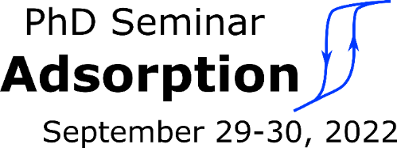
PhD Seminar Adsorption 2022
September 29 – 30, 2022, Erlangen, Germany
Application Form
Last name:
First name:
Institute (incl. address):

E-mail:
Abstract title:

My research topic (mark in bold or color):
- Thermodynamics of adsorption
- Novel adsorbents and their characterization
- Gas phase adsorption
- Liquid phase adsorption and chromatography
- Novel adsorption processes

Please note any food allergies/diet restrictions (e.g., vegetarian, vegan):

Please send this application form until September 20, 2022 to carola.schlumberger@fau.de.
Submission of abstracts is possible until September 15, 2022.
